“THE ANSWERS”

IDEAS TO HELP THE IMPACT OF CHRONIC PAIN

These are the things that people with chronic pain tend to suffer.

Let’s go through them one by one and give you some pointers.

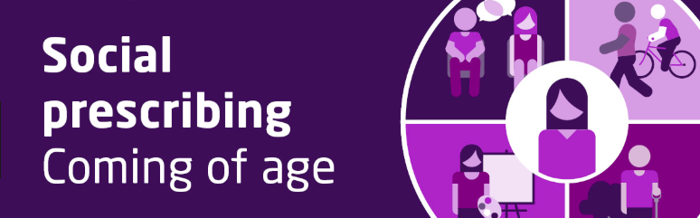
Often we’ll say TALK TO YOUR LINK WORKER – increasingly GP surgeries have a link worker who can see you face to face and signpost you to what’s available in your area – we call it SOCIAL PRESCRIBING.

Click to jump to that section...
- Lack of physical fitness and difficulty exercising
- Social isolation
- Knowing how to self manage chronic pain
- Medications – either they’re not helping enough or side effects
- Understanding why persistent pain happens
- “Boom or bust” – tendencies to do too much on a good day and then paying for it the next i.e. difficulty pacing oneself
- Your weight or eating well
- Sleeping difficulties
- Managing mood changes of depression, anger, anxiety or worry
- Relationship difficulties with partner and family
- Remaining in work or returning to work and/or training
- Financial / money worries

A note for clinicians:
www.livewellwithpain.co.uk is a fantastic resource for you to support patients in self management of chronic pain, there’s lots of video consultations to help you in this challenging but ultimately very rewarding subject

- Lack of physical fitness and difficulty exercising

Very often it is our lack of understanding of pain that makes the pain so much worse. For example, if you believe that walking on an arthritic knee is going to injure your knee further then you’ll avoid that activity. In fact a lot of the time this is exactly what NOT to do! If you avoid activity all the tissues weaken and there is a cascade effect resulting in loss of function and more pain.

Being more active and building fitness can help – even if it was not really part of your life before pain arrived. Three things are important:
1. Stretching helps loosen tight muscles, ligaments and joints and increases flexibility.
2. Strengthening exercises will build stronger muscles and joints and improve balance.
3. Stamina activities help you to do things for longer without more pain or tiredness.

ONLINE RESOURCES:

HEALTHTALK
Patients speak about activity and chronic pain
http://www.healthtalk.org/peoples-experiences/long-term-conditions/chronic-pain/exercise-and-activity-chronic-pain

NHS SITE
https://www.nhs.uk/live-well/exercise/

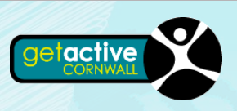
CORNWALL RESOURCES:

http://www.getactivecornwall.co.uk/home/

https://www.walkkernow.co.uk/

LOCAL RESOURCES VIA YOUR LINK WORKER
We’re talking
- yoga
- walking / running clubs
- swimming / water aerobics
- dancing
- tai chi (especially fibromyalgia)

2. Social isolation

Chronic pain usually affects one’s social life to some extent, but it’s important to try to maintain a social life. Sometimes sufferers become very withdrawn because they find company difficult and going out only increased their pain levels.
HEALTHTALK
Here, healthtalk shares patients’ views and we hear about some things that have helped:

http://www.healthtalk.org/peoples-experiences/long-term-conditions/chronic-pain/social-life-and-special-occasions-when-dealing-chronic-pain

INCLUSION CORNWALL
This is an organisation who has plenty of links to other groups and services, particularly around social isolation. Give them a call.
01872 326440
hello@inclusioncornwall.co.uk
http://inclusioncornwall.co.uk/
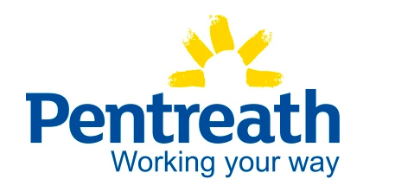

PENTREATH is a Cornish charity particularly specialised in helping people with mental health and emotional problems get back to work. But, of course, pain patients will benefit as well and they also help the socially isolated. You can self refer.
https://pentreath.co.uk/

3. Knowing how to self manage chronic pain

Self management of chronic pain is THE KEY to a brighter future. Pills won’t take it all away, they might take the edge off it. Learning a management strategy for yourself for all occasions – good days, bad days, going out, staying in etc will mean there’s no more fear because you’ve accepted how you are and can live alongside your problems.

As you know, with chronic pain your world gets in a vicious cycle when things go from bad to worse:

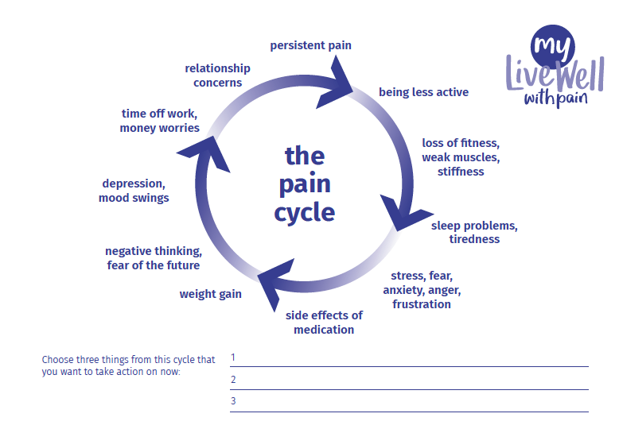

HOWEVER, with support from GPs, physios, family and friends and whatever other support is available, you can learn what we call supported self management where the opposite happens:

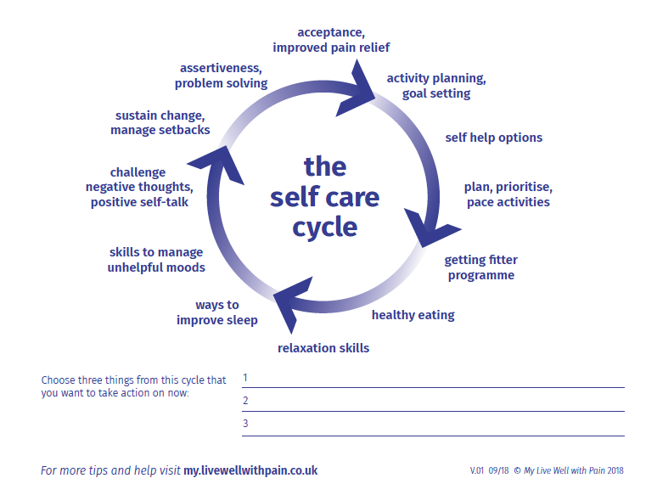

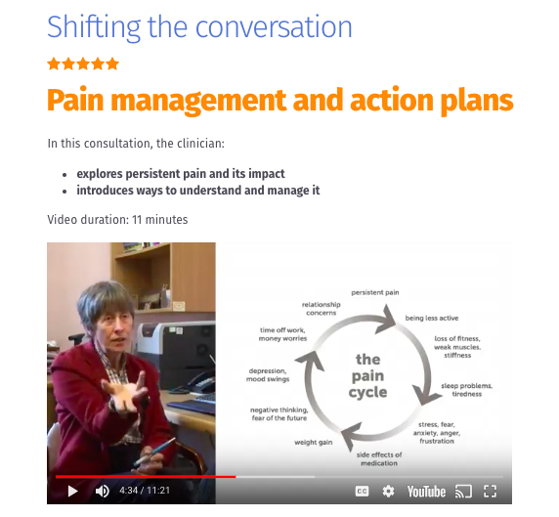
LIVE WELL WITH PAIN website for clinicians
This is all elegantly covered in this video of a consultation by Dr Frances Cole (GP who has been working in the field of chronic pain for decades and many thanks to her for her input)
https://livewellwithpain.co.uk/resources/shifting-the-conversation/pain-management-and-action-plans/

Self management means
- deep understanding of
  - how and why chronic pain arises – it’s not because of tissue damage!*
  - there’s no special pill or person or operation which will take it all away*
- accepting how you are and carving out a life alongside your symptoms
- getting physically fitter
- getting emotionally fitter
- pacing yourself
- dealing with setbacks
- goal setting

- the vast majority of the time

Unfortunately patients are skeptical and think self care means no care – WRONG. Increasingly we’re teaching people with long term conditions to manage it themselves because everybody is different.

The best way to learn self management is from a pain management program from your local pain clinic however if you want to Do It Yourself use these links. It’s possible your family doctor doesn’t know much about this topic, you may be able to teach them!

THE PAIN TOOLKIT
http://www.paintoolkit.org/

Developed in 2002 by Peter Moore, a fellow pain sufferer who says: “Most people depend too much on their Healthcare Professional to solve or get rid of the pain. Many people in pain forget that they have to work together with their healthcare professional in the management of their pain. Pain self management is about learning new (or using old) skills, trying them out and see what works for you. Pain is like a finger print, so each person may need to have individual skills to suit them.”

The website, through the use of reading, videos and a downloadable app provides you with an understanding and a meaning of your pain, 12 tools to use in the “toolkit” for everyday life and a fuller description of the PAIN CYCLE. It will guide you through your journey.
HEALTHTALK
Here, patients talk about their own experience of self management – there’s lots of subchapters down the left side of the page which are relevant:

http://www.healthtalk.org/peoples-experiences/chronic-health-issues/chronic-pain/learning-about-pain-management

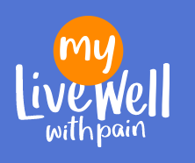
MY.LIVEWELLWITHPAIN
Lots of great stuff here, patient journeys, sleep, medication advice, and, well... as it says on the tin... “live well with pain”

https://my.livewellwithpain.co.uk/

For example
- A psychologist discusses pain and acceptance - https://my.livewellwithpain.co.uk/resources/video-and-audio/

- Podcasts on all sorts of things - https://my.livewellwithpain.co.uk/resources/video-and-audio/podcasts/

- 5 page booklet of self management
https://my.livewellwithpain.co.uk/resources/booklets-and-leaflets/ten-footsteps-to-living-well-with-pain/

- A guide to help you better understand and be in charge of pain
https://my.livewellwithpain.co.uk/wp-content/uploads/Your-Journey-with-Pain-booklet-2.pdf

- Books
https://my.livewellwithpain.co.uk/resources/other-useful-resources/books-about-pain/

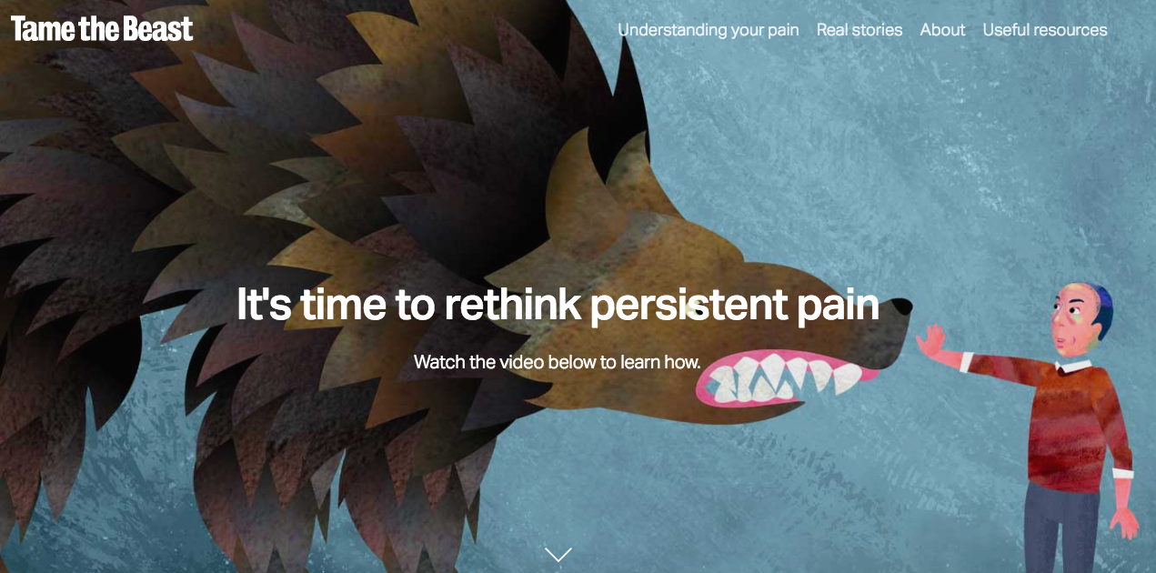
TAME THE BEAST is a website from Australian pain scientists who explain that pain is a “protectometer” alerting us to danger. Except sometimes there is no danger. Lots of great stuff to explore
https://www.tamethebeast.org

SHEFFIELD PERSISTENT PAIN WEBSITE – also has offshoots on specific pain conditions e.g. shoulders, hips
https://www.sheffieldachesandpains.com/persistent/home/

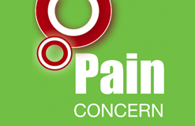
PAIN CONCERN – is a Scottish foundation who have some fantastic self management resources like phone helplines, videos, leaflets, assessment forms:
http://painconcern.org.uk/

Here’s their podcast show – search for the right episode for you:
http://painconcern.org.uk/airing-pain/

VIDEOS
ACCEPTANCE AND ADAPTATION
https://www.youtube.com/watch?v=IvrJ2jIf2zc

COPING WITH SETBACKS
https://www.youtube.com/watch?v=tvSYBvIm09A

GOAL SETTING / BOOM OR BUST
https://www.youtube.com/watch?v=oIIQBK8eK4o

WHAT IS SELF MANAGEMENT?
http://painconcern.org.uk/what-is-self-management/

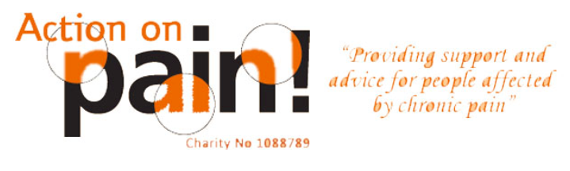
NEED TELEPHONE ADVICE ?– Action On Pain is a charity which has a dedicated telephone helpline in weekday office hours, run by pain sufferers, for pain sufferers:
http://www.action-on-pain.co.uk/

4. Medications – either they’re not helping enough or side effects

Pain-killers not killing your pain? NO SURPRISE THERE! It’s VERY unlikely your pain will go away with pills, the best you can hope for is an improvement and even this is quite rare. Plus, they can cause (sometimes serious) harm.
That said, it doesn’t mean you shouldn’t try appropriate meds to see if they help the pain and more importantly HELP YOU DO THINGS YOU OTHERWISE COULDN’T. The medicines we worry about the most are the opioid drugs because they make your body (no fault of your own) dependent on them and getting off of them can be difficult and very unpleasant indeed. Basically only try them as a last resort and if they don’t help stop them straight away. It’s a dangerous door to open.
You may well be reading this whilst already taking strong painkillers and worried that they’re not working and you’re getting side effects and that you’re at risk of harm. Whether you’re in pain or not, we suggest lowering the doses and maybe even stop for a while to show us whether they’re really helping – read this:
https://www.eclipsesolutions.org/UploadedFiles/320_Explaining%20deprescribing%20opioids.docx

UNDERSTANDING PAIN – BRAINMAN STOPS HIS OPIOIDS – less than 2 minute clip
https://www.youtube.com/watch?v=MI1myFQPdCE

MY.LIVEWELLWITHPAIN has great information on all things medication related:
https://my.livewellwithpain.co.uk/resources/booklets-and-leaflets/

In HEALTHTALK hear about different experiences of drugs both good and bad:
http://www.healthtalk.org/peoples-experiences/long-term-conditions/chronic-pain/introduction-medication-chronic-pain-and-side-effects

5. Understanding why persistent pain happens

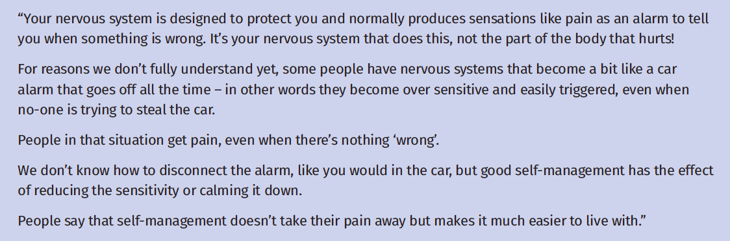

Pain is an unpleasant conscious experience that is constructed by the brain (that doesn’t mean it’s not real by the way!) The brain makes pain as a result of lots of different inputs from the body, different parts of the brain, our memory centers and also our emotional centers and it depends on the context that we’re in. It is designed to protect us.

Remember also that genes are being identified that are associated with chronic pain. Interestingly, there’s an overlap between pain genes and anxiety related genes which might in part explain why they co-exist.
It is not straightforward.

Here’s a few links to try to help explain it:

TAME THE BEAST is a website from Australian pain scientists who explain that pain is a “protectometer” alerting us to danger. Except sometimes there is no danger. Lots of great stuff to explore
https://www.tamethebeast.org/understanding/

A one page leaflet:
https://livewellwithpain.co.uk/wp-content/uploads/pain-and-the-brain-v01.pdf

A 5 page leaflet:
https://my.livewellwithpain.co.uk/resources/booklets-and-leaflets/explaining-pain/

A BRILLIANT 14 minutes video by one of the world’s leading pain scientists: https://www.youtube.com/watch?v=gwd-wLdIHjs

A 5 minute cartoon:
https://www.youtube.com/watch?v=C_3phB93rvI

Books:
https://my.livewellwithpain.co.uk/resources/other-useful-resources/books-about-pain/

UNDERSTANDING HOW PERSISTENT PAIN CAN GET BETTER
VIDEO – Dr Frances Cole explains how things go from bad to worse and how the opposite can happen when you learn the skills you need:
https://livewellwithpain.co.uk/resources/shifting-the-conversation/pain-management-and-action-plans/

6. “Boom or bust” – tendencies to do too much on a good day and then paying for it the next i.e. difficulty pacing oneself

Pacing is taking a break before pain, tiredness or exhaustion force you to stop. Many people use pain to guide their activity levels. On a ‘good day’ they try to get as much done as possible until their pain and tiredness increase, forcing them to stop and rest for much longer. This is called the ‘boom-and-bust’ cycle.

This is covered nicely in the pain toolkit:

THE PAIN TOOLKIT
http://www.paintoolkit.org/

Developed in 2002 by Peter Moore, a fellow pain sufferer who says: “Most people depend too much on their Healthcare Professional to solve or get rid of the pain. Many people in pain forget that they have to work together with their healthcare professional in the management of their pain. Pain self management is about learning new (or using old) skills, trying them out and see what works for you. Pain is like a finger print, so each person may need to have individual skills to suit them.”

The website, through the use of reading, videos and a downloadable app provides you with an understanding and a meaning of your pain, 12 tools to use in the “toolkit” for everyday life and a fuller description of the PAIN CYCLE. It will guide you through your journey.

GOAL SETTING / BOOM OR BUST VIDEO
https://www.youtube.com/watch?v=oIIQBK8eK4o

5 page booklet of self management includes pacing amongst other skills
https://my.livewellwithpain.co.uk/resources/booklets-and-leaflets/ten-footsteps-to-living-well-with-pain/

7. Your weight and eating well

Eating well and having a normal-range weight will help you to build better health and cope well with pain. There are many things that you can do to help achieve a healthy weight – and they don't always involve a diet! Ask your doctor or pharmacist for a medication review, as some drugs can contribute to weight gain. Reducing portion sizes, cutting out snacks and switching to a Mediterranean diet can help, too.

TALK TO YOUR LINK WORKER

Also, check out CORNWALL HEALTHY WEIGHT to get involved, for kids and adults including pregnancy
https://www.cornwallhealthyweight.org.uk/

NHS sources
https://www.nhs.uk/live-well/eat-well/
https://www.nhs.uk/live-well/healthy-weight/

8. Sleeping difficulties

Many people with pain find that their sleep is disrupted. New research shows that by adjusting what you do during the day, as well as night, it is possible to achieve a healthier sleep pattern.

SLEEP WELL WITH PAIN LEAFLET looks at five areas - daily routines, activity levels, food and drink choices, night-time routines, helping mind and body to rest
https://my.livewellwithpain.co.uk/resources/booklets-and-leaflets/sleep-well-with-pain-leaflet/

AND THIS HAS A BIT MORE DETAIL
https://my.livewellwithpain.co.uk/wp-content/uploads/Sleeping-Problems-A4-2016-FINAL.pdf

HEALTHTALK – patients talk about pain and sleep
http://www.healthtalk.org/peoples-experiences/long-term-conditions/chronic-pain/sleep-stress-and-environmental-factors-chronic-pain

SLEEPIO is web based sleep orientated CBT course.
https://www.sleepio.com/
It has shown benefit in THE LANCET medical journal
https://www.thelancet.com/journals/lanpsy/article/PIIS2215-0366%2817%2930328-0/fulltext

CALM is a meditation and sleep teaching app
https://www.calm.com

The section on managing your emotions should help your sleep too

9. Managing mood changes of depression, anger, anxiety or worry using
MINDFULNESS AND MEDITATION TECHNIQUES

It is normal to struggle with moods when you have persistent pain. People often feel angry, frustrated, fearful and unmotivated because of it.

Here are some things that you can do to manage your moods better:
- Notice negative and unhelpful thoughts, and find ways to balance or soothe them.
- Practise balanced thinking – imagine what a best friend would say if they knew what you were thinking. Ask yourself, ‘Are my thoughts 100 per cent true and believable?’
- Do things that unwind and soothe your mind, such as walking the dog, listening to music and breathing calmly.
- Create a list of positive things you have done that day or week
- Practise being kind to yourself by pacing and giving yourself pleasurable rewards
- Learn from others with similar pain issues
- Find out about self-help resources to manage your moods
- Share your plans with people you trust and get their support.

Easier said than done huh??!! This takes time, dedication and practice, like getting physically fit.

VIDEO
One way is a better understanding of your pain helps reduce your pain
http://painconcern.org.uk/emotional-impact-of-chronic-pain/

Another technique and skill you might of heard of is MINDFULNESS and MEDITATION. They are skills which allows you to familiarise yourself better with who you are and how you are feeling both physically and emotionally. Almost like overseeing your feelings and emotions from another place, a less critical place which isn’t stuck in the past or the future. It is a spiritual exploration, though not religious. It really does help.

There are oodles of websites, podcasts, videos out there. Try to find something that works for you.

Here are some pointers:
HEALTHTALK – people talk about their emotions and some skills like acceptance, self-compassion, distraction techniques
http://www.healthtalk.org/peoples-experiences/long-term-conditions/chronic-pain/coping-emotional-impact-chronic-pain

NHS info
http://www.nhs.uk/conditions/stress-anxiety-depression/pages/mindfulness.aspx
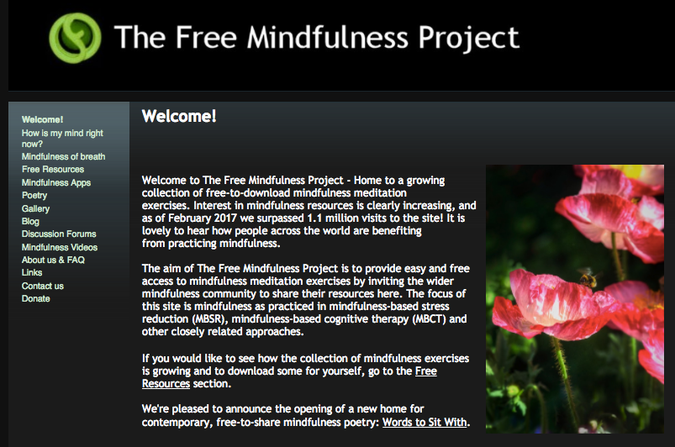
The Free Mindfulness Project provides easy and free access to mindfulness meditation exercises such as mindfulness-based stress reduction (MBSR), mindfulness-based cognitive therapy (MBCT) and other closely related approaches.
http://www.freemindfulness.org/

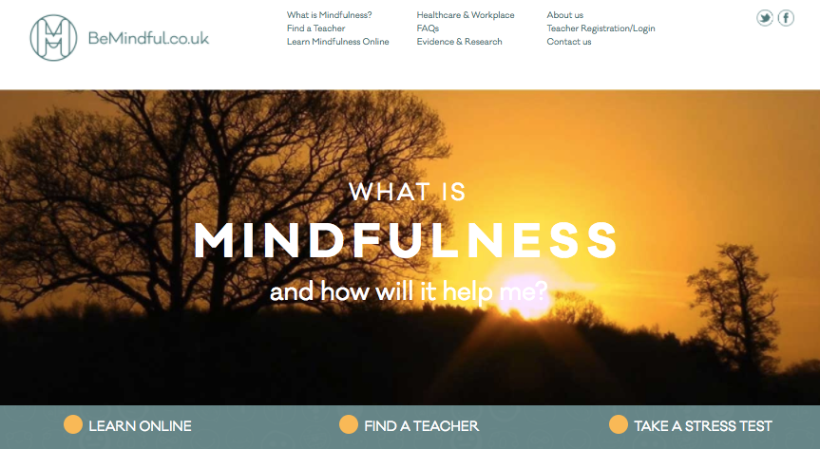
The BeMindful website provides an online course which provides a 4 week course in mindfulness practice (it can be completed at a slower pace). The cost is £30 however the introduction is free.
http://www.bemindful.co.uk

MINDFULNESS COLOURING BOOKS
This sounds a bit odd but these books are massive sellers online with good consumer reviews. They say it’s a great distractor and anxiety reliever

LEARN TO MEDITATE
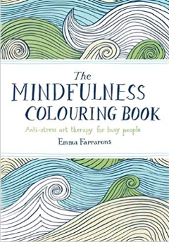
Meditation and mindfulness are kind of the same thing but you could see meditation as a deeper state of concentration whilst mindfulness we carry around 24/7.

HEADSPACE is an app based meditation course which is enormously successful. Developed by Andy Puddicombe (who ordaned as a Buddhist monk) it brings together traditional teaching with modern science. There are ongoing medical trials investigating the benefits to health and wellbeing
https://www.headspace.com/

Local mindfulness courses
Outlook South West is an NHS counseling services who run mindfulness courses (no cost) – you can self refer
http://www.outlooksw.co.uk/mindfulness

Mindfulness Cornwall offers a range of mindfulness based approaches including
- 8 week courses
- training days
- mindful yoga
- one-to-one mindfulness based therapy

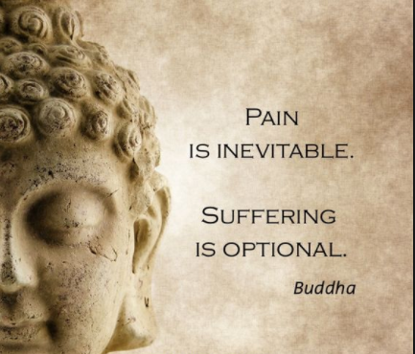
REMEMBER that mindfulness and meditation based treatments have evolved from Buddhist teachings that go back 2,500 years! That is some track record and really fascinating. If you want to seek out the source of this movement, try some of these. PLEASE NOTE – this is not religious teaching – it is a way of being which is just as relevant now as it was thousands of years ago.

These teachings also add wholesome skills like compassion, kindness and understanding impermanence as ways to alleviate suffering. All good stuff.

Get meditating in 14 minutes with this video from a respected monk. His English isn’t great but his teachings are...
https://www.youtube.com/watch?v=5GSeWdjyr1c

BUDDHIST BASED MEDITATION PODCASTS
https://www.tarabrach.com/new-to-meditation/
https://www.sharonsalzberg.com/metta-hour-podcast/
https://www.audiodharma.org/
https://oneminddharma.com/

10. Relationship difficulties with partner and family

Connecting with others can feel like the last thing you want to do when pain dominates your life. Yet doing things with other people is likely to lift your mood and distract you from focusing on your pain. It can also motivate you to do more of the activities you enjoy.

It can be very stressful for partners and families to see loved ones in pain. Sometimes sufferers can take out their frustrations on those close to them. Emotional support is very helpful and sometimes, weirdly, it can bring folk closer together.
HEALTHTALK - Hear some patients talk about it:
http://www.healthtalk.org/peoples-experiences/long-term-conditions/chronic-pain/impact-chronic-pain-family

Intimate relationships become strained as well...
http://www.healthtalk.org/peoples-experiences/chronic-health-issues/chronic-pain/relationships-and-sex-life

WHAT TO DO ABOUT IT? Get yourself as well and as fit as you can using skills from the other sections and COMMUNICATE how you are to your loved ones. They will want to help, and they can help.
11. Remaining in work or returning to work and/or training

Staying at work or returning to work gives your life routine, structure and purpose. Here are some tips that can help:
- Think about what needs to happen for you to return to work
- If you are looking for work, be flexible about what you might do
- Ask for a phased return starting with just two to three hours per day and building up from there
- Be prepared to accept any support that is offered at work.

If you’re in work but you need to adapt the hours or your duties, see your GP who can write a “fit note” which will encourage your employer to work with you to keep your job. It’s another example of learning to live alongside your pain rather than “beating it”

HEALTHTALK - Having to stop work is a devastating loss not just financially but also of your career and your independence. Hear what patients have to say:
http://www.healthtalk.org/peoples-experiences/long-term-conditions/chronic-pain/unemployment-and-returning-work-chronic-pain

CORNWALL RESOURCES if you’re out of work:
PENTREATH is a Cornish charity particularly specialised in helping people with mental health and emotional problems get back to work. But, of course, pain patients will benefit as well. They also help the socially isolated. You can self refer.
https://pentreath.co.uk/

THROUGHTHE JOBCENTRE
They have DEA’s – disability employment advisors who can see you and help you find out what work could suit you and how to get you prepared for it:
https://www.supportincornwall.org.uk/kb5/cornwall/directory/service.page?id=dshNQpl0X6w

https://www.jobcentreguide.co.uk/jobcentre-plus-guide/34/disability-employment-advisors

12. Financial / money worries

It’s not unusual for chronic pain sufferers to get into debt. Luckily we have the Cornwall Citizens’ Advice Bureau to help out
https://www.citizensadvicecornwall.org.uk/

